**Full Name: ____________________________**

**Class Exercise Challenge #7**

**GAME 2343/2347 and IMED 1345/2345**

After today’s lecture and hands on activities, you will need to complete the following challenge:

1. Create a C# script, call it Ternary, create a public field for the players name, if there’s value in it, then Unity should write “Hello…” with the value, follow by the players name, if the name is empty or null, it should write “Hello Player 1”. To check if it’s empty, use this code:

playerName != “”

Have the text print out when the cube is disable.

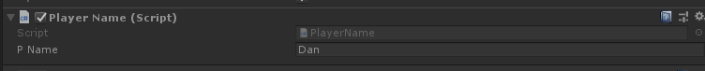

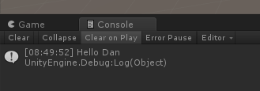

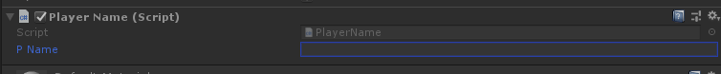

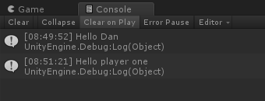

2. Toggle between the two states (checked and unchecked), you will need to take the screen shot, copy and paste it below.

3. Upload this document to eCampus before the due date.